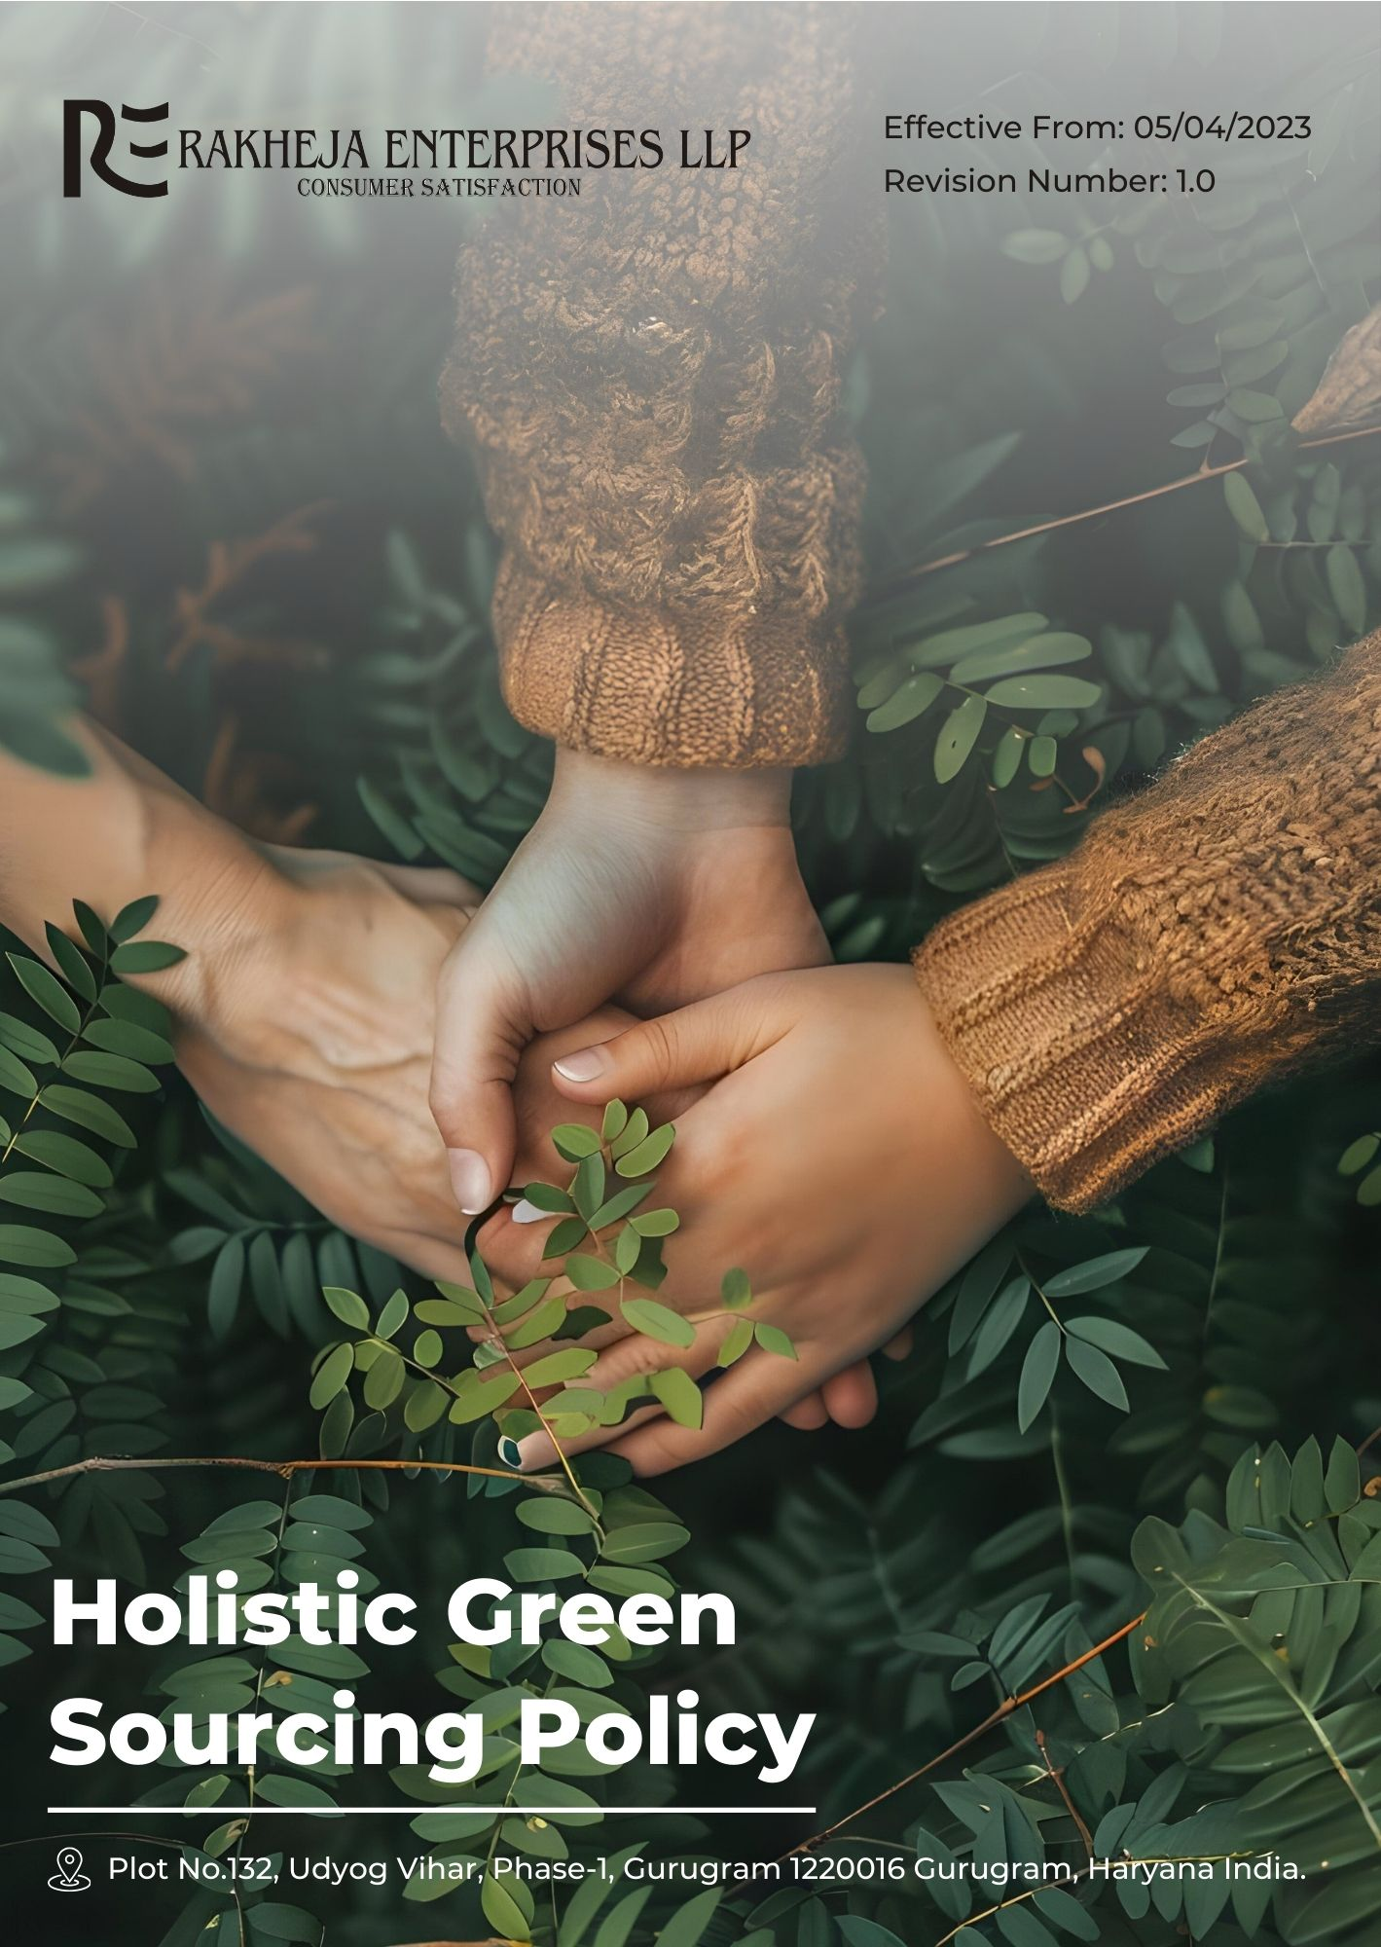
Table of Contents
1. Introduction 3
2. Planned objectives 3
3. Scope 3
4. Rakheja’s Green Sourcing key strategies and targets 4
5. Responsibility 5
6. Reporting 5
7. Continuous Improvement 7
8. Review Cycle 8
9. Acknowledgement by Employee 9

Introduction
At Rakheja Enterprises LLP, we are committed to implementing sustainable and environmentally friendly sourcing practices throughout our textile supply chain. This Holistic Green Sourcing Policy emphasizes the use of eco-friendly materials, ethical production processes, and responsible supplier partnerships to minimize our environmental impact and promote sustainability in the textile industry.

Planned objectives
- Sustainable Materials: Prioritize the use of organic, recycled, and eco-friendly fibers in our textile production.
- Ethical Production: Ensure all stages of production adhere to fair labor practices and environmental standards.
- Water Conservation: Implement water-efficient processes and promote water recycling in textile manufacturing.
- Chemical Management: Minimize the use of harmful chemicals and promote safer alternatives in textile processing.
- Waste Reduction: Implement circular economy principles to reduce waste and promote recycling in our supply chain.
- Transparency: Maintain clear communication about our sourcing practices and environmental impact.

Scope
This Policy applies to all employees (at all levels), all stakeholders, partners, contractors, customers, suppliers, and any other individual or entity working on behalf of Rakheja Enterprises LLP. It also applies to all our manufacturing facilities as well as It covers all stages of the textile supply chain, from raw material sourcing to final product delivery.

Rakheja’s Green Sourcing key strategies and targets
- Supplier’s Environmental issue :
- To reduce our carbon footprint, we are implementing a strategy to source sustainable fibers locally, aiming to cut transportation emissions by 25% by FY 2025-26 from the baseline FY 2022-23.
- To minimize environmental impact, we are partnering with eco-friendly dyeing facilities, aiming to reduce water usage by 15% by FY 2025-26 from the baseline FY 2022-23.
- We strive for 100% adoption of eco-friendly packaging among our suppliers to promote sustainable practices throughout the supply chain by FY 2025-26 from the baseline FY 2022-23.
- We aim to achieve full compliance with our code of conduct among all suppliers by FY 2025-26, ensuring responsible environmental practices are upheld across our supply chain, starting from the baseline in FY 2022-23.
- Supplier’s Social issue :
- To ensure fair labor practices, we have implemented regular audits of textile suppliers, aiming for 100% compliance with labor standards by FY 2025-26 from the baseline FY 2022-23.
- To support local communities, we are committed to sourcing materials from local artisans, aiming to increase local procurement by 35% by FY 2025-26 from the baseline FY 2022-23.
- To enhance diversity in our partnerships, we aim to have 15% of our suppliers be businesses owned by underrepresented groups by FY 2025-26 from the baseline FY 2022-23.
- Other targets:
- We prioritize equitable pricing to ensure fair compensation for textile workers and aim to increase fair trade-certified textile procurement by 25% by FY 2025-26 from the baseline FY 2022-23.
- To support small and medium-sized textile enterprises, we have introduced a supplier development initiative, aiming to boost SME participation by 30% by FY 2025-26 from the baseline FY 2022-23.

Responsibility
- Senior Management
- Senior Management is responsible for overseeing the implementation and adherence to the Holistic Green Sourcing Policy. They ensure that the policy aligns with the company's overall strategic objectives and sustainability goals.
- Sourcing and Procurement team
- The Sourcing and Procurement Team is responsible for review and operationalizing the policy by engaging with suppliers, conducting assessments, and ensuring compliance with ethical and environmental standards. They play a crucial role in selecting and managing supplier relationships based on the principles outlined in the policy.
- Sustainability and Compliance Officers
- Sustainability and Compliance Officers monitor compliance with the policy, provide guidance to the procurement team, and ensure that all sourcing activities align with applicable laws and regulations. They are also responsible for conducting regular audits and assessments.
- Employees
- All employees are expected to understand and uphold the principles of the Holistic Green Sourcing Policy in their respective roles. They are encouraged to report any concerns or violations related to sourcing practices.

Reporting
Transparent and regular reporting is essential for monitoring the effectiveness of our Holistic Green Sourcing Policy, ensuring accountability, and promoting continuous improvement. The following reporting procedures are implemented:
- Regular Sourcing Performance Reports
We conduct annual evaluations of our sourcing practices, gathering data on key metrics outlined in our Holistic Green Sourcing Policy. These reports provide a comprehensive assessment of compliance with ethical and environmental standards, supplier performance, and progress towards our sustainability objectives. They include:
- Compliance Evaluation: Assessment of adherence to the policy's principles, including labor standards, environmental impact, and supplier code of conduct.
- Progress Tracking: Measurement of achievements against our policy objectives, such as the percentage of sustainable materials used, waste reduction, and energy efficiency improvements.
- Internal Audits
Internal audits are conducted to evaluate compliance with the Holistic Green Sourcing Policy and the effectiveness of our sourcing management systems. These audits:
- Assess Policy Adherence: Evaluate the extent to which sourcing activities comply with established policies and procedures.
- Identify Improvement Areas: Highlight areas requiring corrective actions and opportunities for enhancing our sourcing practices.
- Stakeholder Engagement
We actively engage with stakeholders, including employees, suppliers, customers, and industry experts, to:
- Solicit Feedback: Gather input on our sourcing practices, policy effectiveness, and areas for improvement.
- Address Concerns: Respond to stakeholder inquiries and concerns, ensuring that their perspectives are considered in our sourcing decisions.
- Communicate Performance: Share updates on our sourcing practices, policy changes, and sustainability achievements.

Continuous Improvement
We will regularly review and update our sourcing practices based on performance data, stakeholder feedback, and emerging sustainability trends. Each year, we will conduct comprehensive assessments to identify opportunities for enhancing our environmental and social impact. We will integrate new technologies and innovative solutions to further reduce our carbon footprint, optimize resource use, and improve supplier practices. Our commitment to ongoing training for employees and suppliers will ensure adherence to evolving best practices. By maintaining an open dialogue with stakeholders and incorporating their insights, we will continuously refine our strategies to achieve superior sustainability outcomes and drive progress in our textile supply chain.

Review Cycle
The Compliance Officer will oversee a biennial review cycle of our Holistic Green Sourcing approach to ensure its effectiveness and relevance. This review will involve a comprehensive assessment of policy adherence, including environmental and social impacts. The Compliance Officer will analyze performance data, audit results, and stakeholder feedback to identify areas for improvement. They will update the policy to reflect new regulatory requirements, industry standards, and emerging best practices. Additionally, the Compliance Officer will communicate any changes to relevant parties and ensure the revised policy is effectively implemented across all operations. This biennial review process is essential for maintaining high standards of compliance and driving continuous improvement in our sourcing practices.
Prepared By (Name) | Compliance Officer
Date of Preparation | 27/03/2023
Prepared by (Signature)
Approved By | General Manager
Date of Approval | 31/03/2023
Signature of Approver
Implementation Date | 05/04/2023
Next Review Date | 01/04/2025

Acknowledgement by Employee

I acknowledge that I have received, read, and understood Rakheja Enterprises LLP's Holistic Green Sourcing Policy. I am aware of the principles and guidelines outlined in the policy, including our commitment to sustainable materials, ethical production practices, water conservation, chemical management, waste reduction, and transparency.
I understand that it is my responsibility to adhere to these practices in my role and to report any concerns or violations related to our sourcing practices. I also recognize that failure to comply with the policy may result in disciplinary action.
By signing this form, I confirm my commitment to upholding the standards set forth in the Holistic Green Sourcing Policy and contributing to the company’s sustainability goals.
Employee Name
Acknowledgement Date
Signature

